**J101927 – Website Documentation**

[http://2209041.linux.studentwebserver.co.uk](http://2209041.linux.studentwebserver.co.uk/)

Contents

Design Process: 1

Gathering Ideas for the design: 1

Wireframe: 3

Change Notes 6

Adding More Buttons: 6

Changed The Format of Each Page: 8

References 10

## Design Process:

### Gathering Ideas for the design:

Before developing the website, information was gathered from the inspiration of other websites related to the chosen topic.

Automatically adding a header, a footer, and a navigation system was vital for the website. Adding these would ensure that the user had full access to and understanding of the web pages.

Based on research, one recurring factor analysed on each website was using a background image, and the websites would do this to engage their audience.

Examples below:

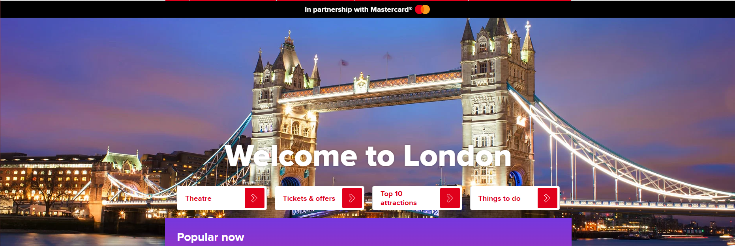

Figure 1: Visit London’s home page (screenshotted for this report)

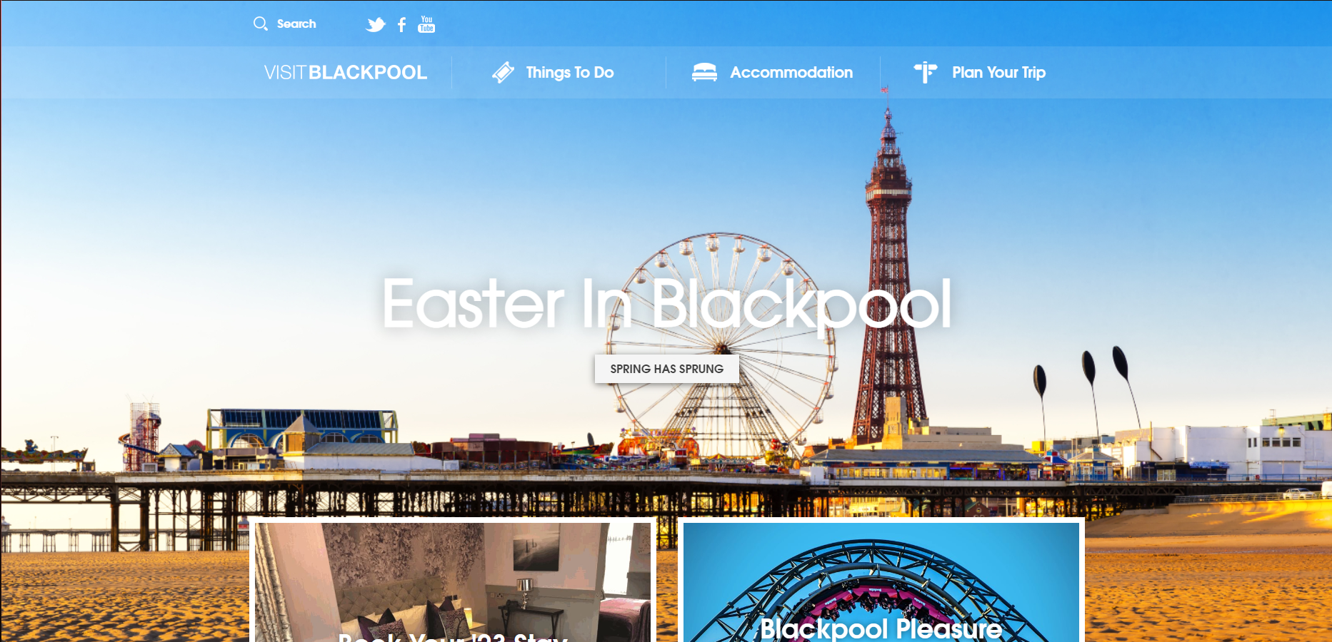

Figure 2: Visit Blackpool’s home page (screenshotted for this report)

Furthermore, another reoccurring theme was using grids to structure information such as headings or sections of the website.

Examples:

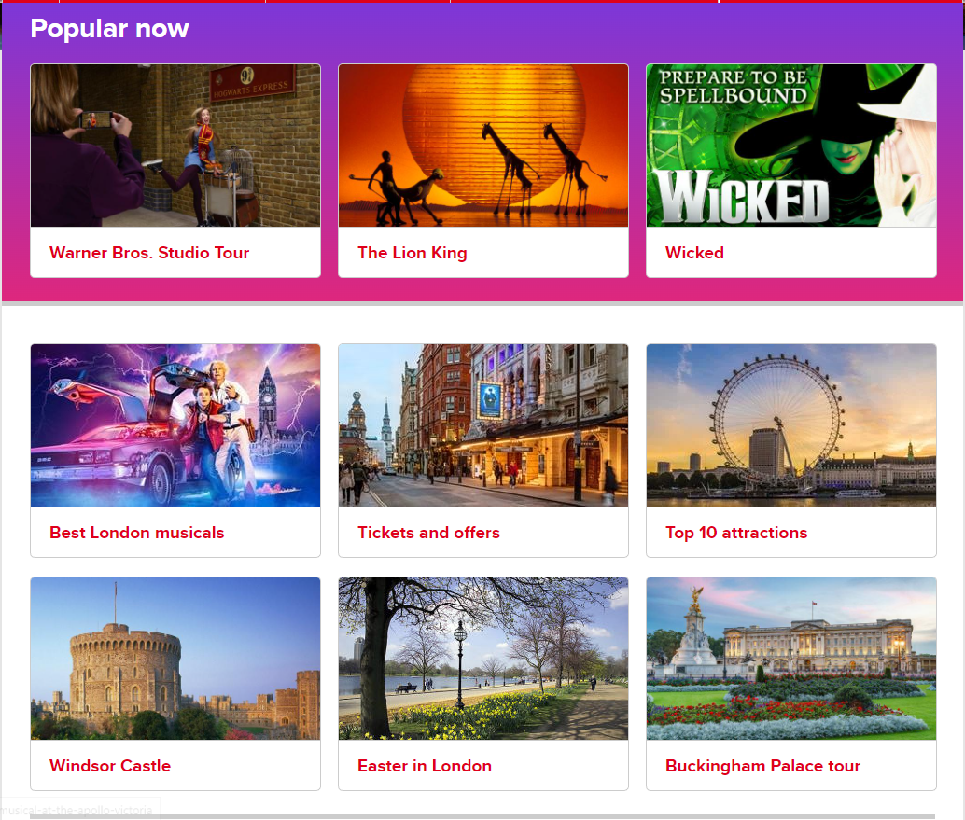

Figure 3: Visit London’s website (Link in references) (Screenshotted for this report)

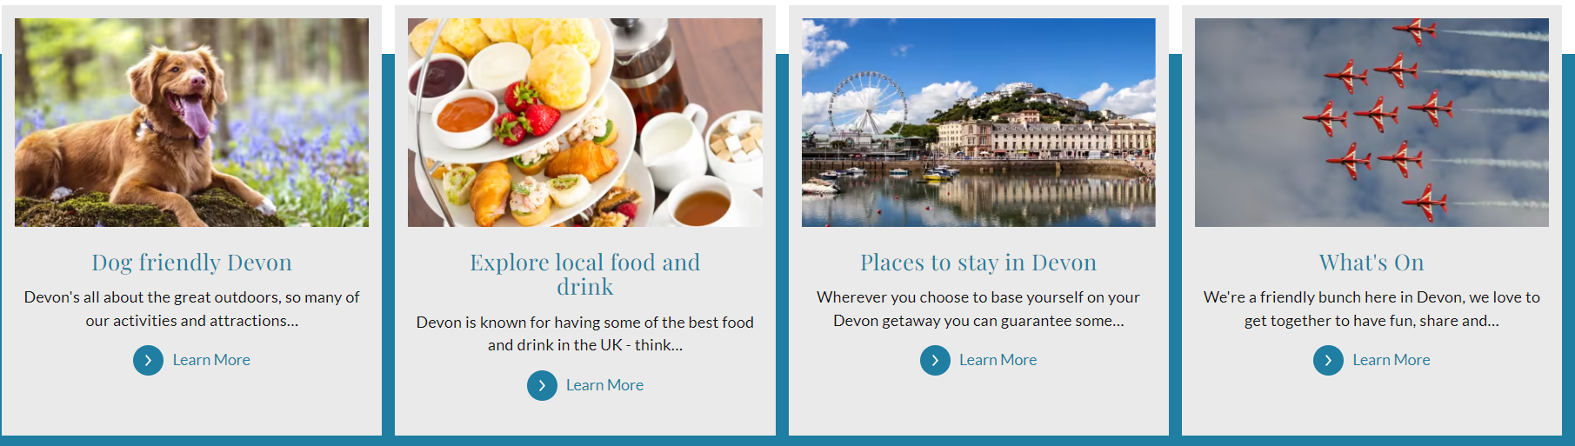

Figure 4: Visit Devon’s website (Screenshotted for this report)

As well as looking for design ideas using other websites, the requirements in the assignment brief had to be implemented to meet the criteria. This included:

* Website containing at least five pages with different/relevant content.
* Must include three external links to other websites.
* Must be implemented using CSS.
* Comments need to be implemented in the HTML and CSS code.

### Use of Tutorials:

Although gathering information through other websites was useful, watching web development tutorials gave me a platform to help create the design. Watching tutorials made the design look more professional and creative than other local websites.

Furthermore, having access to tutorials allowed me to gain further knowledge that may have yet to be introduced in the lectures.

### Wireframe:

After gathering and addressing all the design ideas, a wireframe was created; this was critical as it gave a clear and brief idea of what the website will look like and the relationships between each page. Creating a wireframe was also vital as it allowed the development of the website on a smartphone.

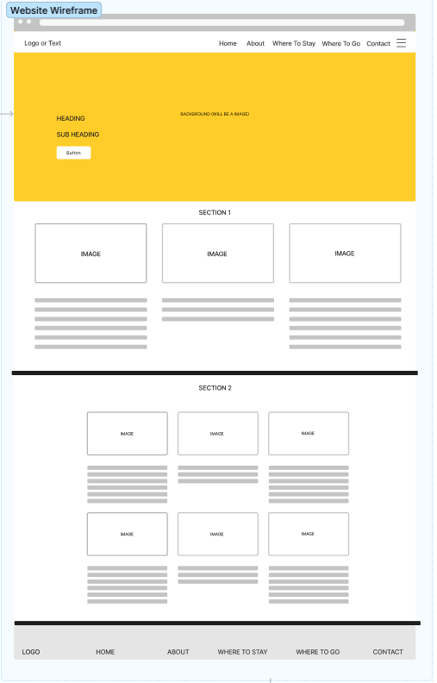

Figure 5: Wireframe for the website on a computer screen (created for this report)

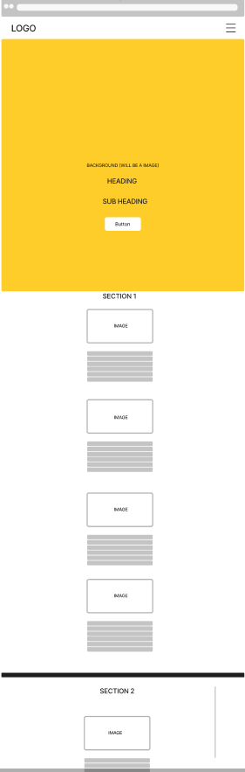

Figure 6: Wireframe of the website on a smartphone (created for this report)

As shown in Figure 5 and Figure 6, the website would have a clear and professional navigation system on the top and bottom of the page, allowing users to navigate through each of the five pages. As you can see in figure 6, however, we make more use of the hamburger menu due to a smartphone having a smaller screen size.

Furthermore, the website would also display a background image, which was implemented to make the website more user-friendly. Additionally, the website’s index page would include two sections that attract the user’s attention through a grid format. Also, figures 5 and 6 have all the minimum requirements for the assignment brief.

## Change Notes

### Adding More Buttons:

To meet the minimum requirements, more buttons were added to the content. Doing this would increase the number of external links the user could use. Additionally, adding this change to the design would be necessary as it would also reference where the information was gathered.

Wireframe design before development:



Figure 5: Wireframe for the website on a computer screen (created for this report)

Index page after the start of development:

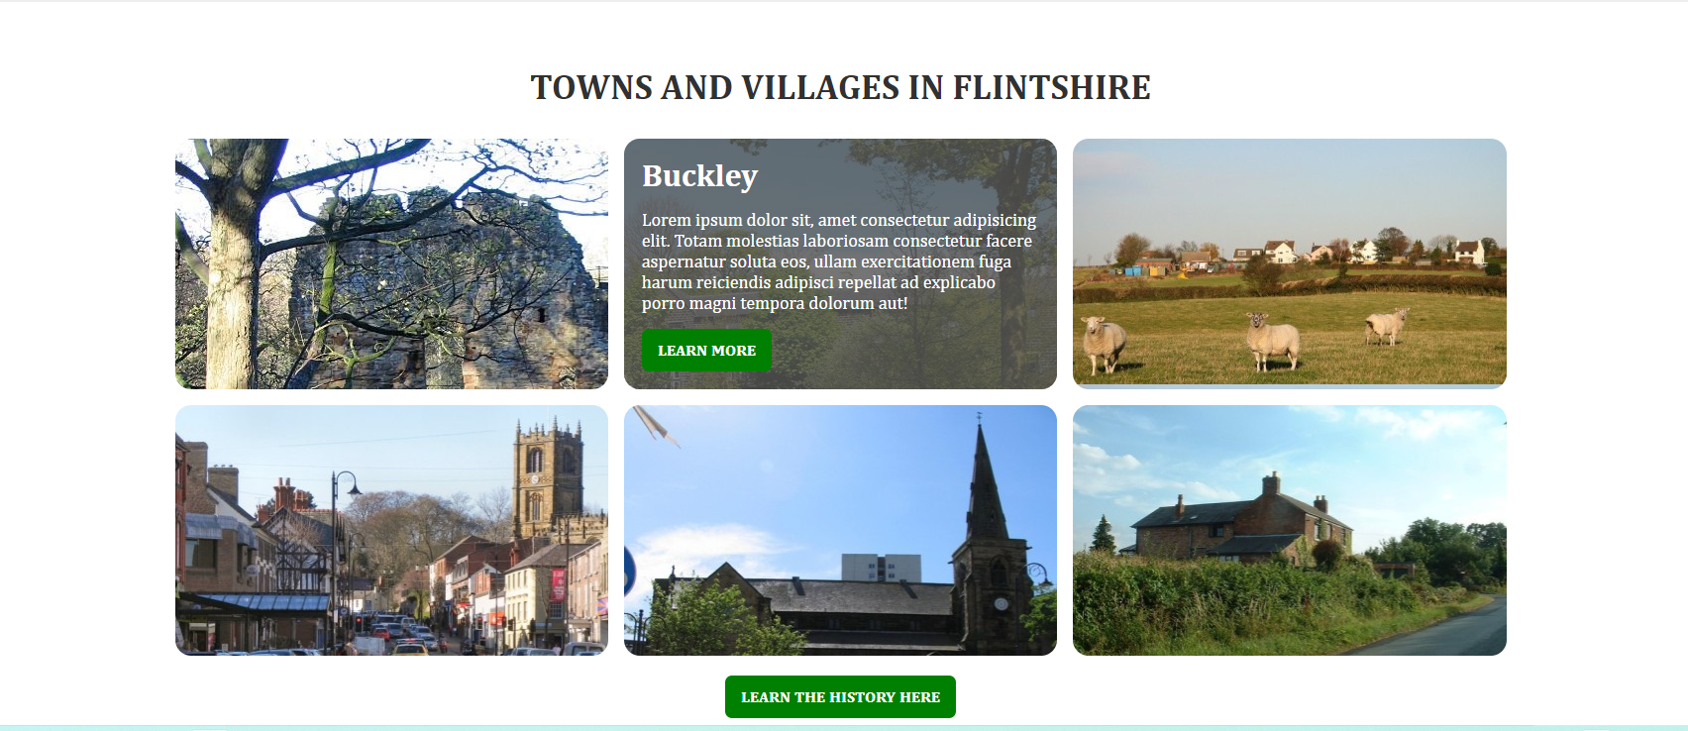

Figure 7: Home page of the developed website (created for this assignment)

### Changed The Format of Each Page:

To ensure that each page looks different and unique, the format for each page was changed. Implementing this would bring freshness to the website and keep the user interested and invested in the website.

Examples of two of the pages:



Figure 7: Home page of the developed website (Created for this assignment)

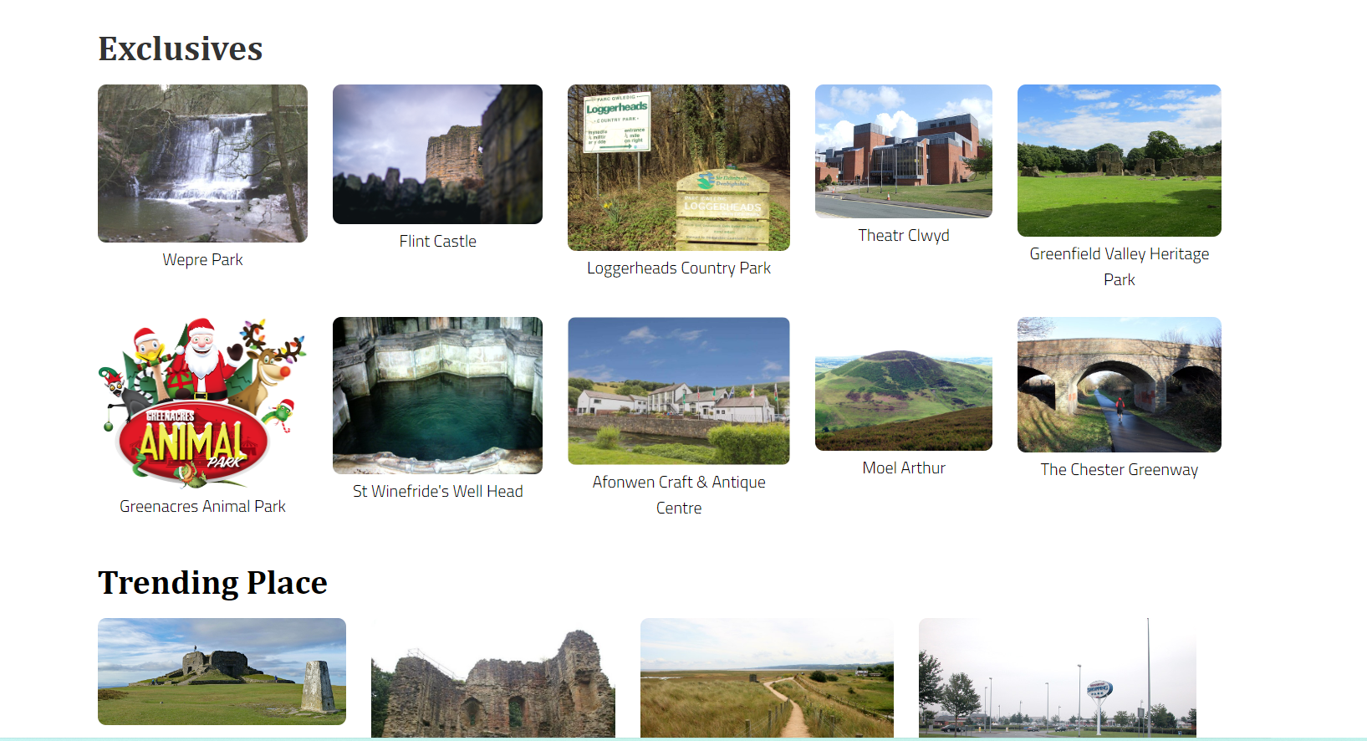

Figure 8: Where to Go page of the developed website (Created for this assignment)

### Accessibility Requirements:

For everyone to use my website, I implemented several accessibility features. One of the first accessibility features that were implemented was img alt text. Img alt text allows a user that relies on text to find out what the graphical image is.

Example of alt text being implemented in my code:

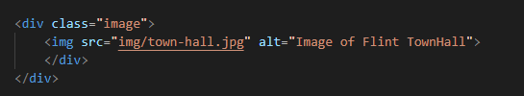

Figure 9: Code from my index.html

Another accessibility feature is the use of accessible hyperlinks. Because hyperlinks are vital in a website, they must be clear, visually appealing, and accessible. Having this knowledge, I created a button for each hyperlink. Doing this will allow users to move from website to website quickly and easily.

Example of accessible hyperlinks on my website:

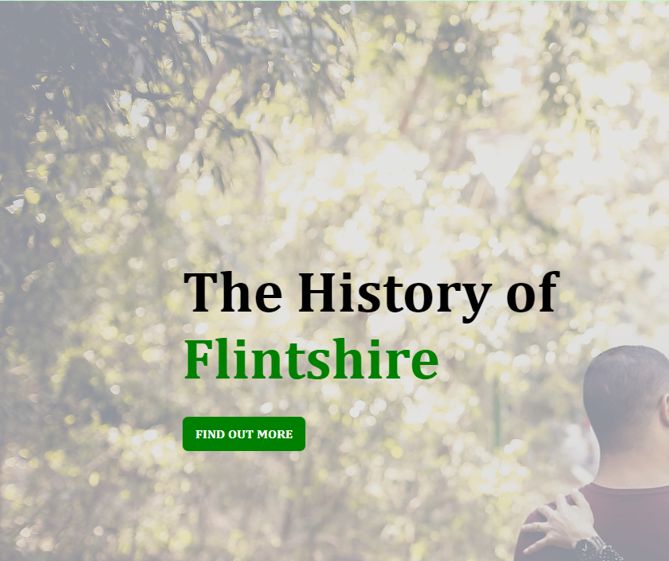

Figure 10: My chosen websites about page

Lastly, an accessibility feature that has been applied across the whole of the website is the use of consistent navigation. Applying this allows a user to use the website without running into any errors. I also made certain that the navigation is in the same place, so it doesn’t confuse the user.

## References

*Creative commons*. CC Search Portal. (n.d.). Retrieved March 27, 2023, from https://search.creativecommons.org/ (Images)

*Explore more than 700 million creative works*. Openverse. (n.d.). Retrieved March 27, 2023, from https://openverse.org/ (Images)

projects, C. to W. (2023, March 5). Wikimedia Commons. Retrieved March 27, 2023, from https://commons.wikimedia.org/wiki/Main_Page (Images)

Unsplash. (n.d.). *Beautiful free images & pictures*. Unsplash. Retrieved March 27, 2023, from https://unsplash.com/ (Images)

YouTube. (2021). *Build a Responsive Spa Website using Html & Css ~ Portfolio Page Tutorial*. *YouTube*. Retrieved March 28, 2023, from https://www.youtube.com/watch?v=XxtxO-5VecQ&list=LL&index=39.

*W3Schools free online web tutorials*. W3Schools Online Web Tutorials. (n.d.). Retrieved March 29, 2023, from https://www.w3schools.com/